Language Modeling
- According to your flow chart, what kind of interference does the N-grams model face when processing text? How does TF-IDF address this issue?
- N-grams模型容易收到高频词的干扰，TF-IDF通过降低这些高频词的权重来解决这个问题

- What is the core obstacle FFNN faces when processing sequences? How does RNN solve this problem?
- FFNN无法处理变长序列的问题，RNN通过其循环结构设计来解决这个缺陷

Word Embeddings
- What vector representation problem do both N-grams and TF-IDF face? How does FFNN solve it?
- TF-IDF和N-grams都面临稀疏向量的问题，FFNN引入了dense vector来解决这个问题
- What model is Word2Vec essentially the same as? How does it achieve faster training speeds?
- Word2vec本质上和FFNN是一样的，它通过显著滑动窗口的大小来实现更快的训练

FFNN
- Please explain why activation functions (e.g., ReLU) must be introduced between Fully Connected (FC) layers in an FFNN? Mathematically, what does a multi-layer neural network become if these activation functions are omitted?

- Role of the activation function in FFNN: activation function can introduce non-linearity into the model, which can help the model learn deeper representations
- If these activation functions are omitted, the multi-layer neural network will be purely linear model

- Role of activation function
- Introduce non-linearity: FC layers by themselves perform linear matrix multiplications. Activation functions like ReLU inject non-linearity, enabling the model to learn and approximate complex, non-linear mappings. 全连接本身执行的是线性矩阵运算。激活函数引入了非线性，使得模型能够学习和逼近复杂的、非线性的函数关系。
- Representation power: non-linear activations allow the network to build increasingly deep and abstract representations through layered stacking 非线性激活函数允许网络通过层层叠加来构建更加深层的语义表示

- Mathematical collapse of linear layers
  - Mathematical nature: without an activation function, every layer is merely a linear transformation (y=Wx+b) 数学本质：如果没有激活函数，每一层都只是一个线性变换
  - Outcome: the composition of multiple linear transformations remains a linear transformation. Mathematically, W2x(W1x+b1)+b2 can be simplified into a single linear form W’x+b’ 多层线性变换的复合仍然是一个线性变换
  - Model limitation: this implies that a 100-layer network without activations is functionally equivalent to a simple single-layer perceptron, rendering it incapable of solving non-linear separable problem 这意味着一个没有激活函数的100层网络在表达能力上和一个简单的单层感知机完全相同，无法处理非线性可分的数据

- According to the Universal Approximation Theorem, a two-layer MLP with sufficient width can theoretically approximate any continuous function. If so, why do we prefer increasing the depth of the network in practice rather than just increasing its width?
- Parameter efficiency
  - Core logic: some complex functions require an exponential number of hidden units to be approximated by a two-layer MLP 某些复杂的函数如果使用两层的MLP来逼近，可能需要指数级别的神经元
  - Advantage of depth: in contrast, increasing the number of layers can achieve the same level of approximation with only a polynomial number of parameters. This makes deep networks significantly more efficient in terms of memory and computation 相比之下，增加层睡可以使用多项式级别的参数量来实现相同的逼近效果。这意味着深层网络在达到相同精度的时候，参数更少，计算更加高效
- Hierarchical feature representation
  - Deep networks can learn representations by stacking layers, evolving from simple to highly complex features 深层网络通过层层叠加，可以学习到从简单到复杂的特征表示
  - Lower layers capture general features (like edges), while deeper layers combine these to identify complex semantic objects (like faces or object outlines). This hierarchical structure aligns with the nature of real-world data. 浅层学习通用的基础特征，深层通过组合这些特征来识别复杂的对象。这种层次化的结构更加复合世界数据的生成逻辑
  - Better generalization
    - Indutive bias: the deep architecture imposes a beneficial constraint that encourages the model to learn robust, layered features, whereas an extremely wide single-layer network is more prone to memorizing training data 归纳偏置：深度结构带有一种有益的约束，迫使模型学习更加具有稳健性的分层特征，然而极宽的单层网络更容易陷入对训练数据的死记硬背

- FFNNs require fixed input dimensions, yet sentence lengths vary. Combining the concept of "Representation Learning," list two common aggregation methods used to convert a variable-length sequence of word embeddings (LxD) into a fixed-length vector (1xD) acceptable by an FFNN.
- Average pooling: suppose L is the sequence length, D is the embedding dimension of each token. Compute the average of each token embedding
- Linear layer: use a linear projection with the Lx1 matrix 这个不可行，一般要先进行池化，再将定长的向量送入线性层

- Average Pooling
  - Method: computes the arithmetic mean of all token embeddings across the sequence length L 计算序列中所有token嵌入向量的算数平均值
  - Outcome: produces a fixed 1xD vector regardless of the original sequence length, representing the global semantic average 无论序列长度L是多少，最终都会得到一个1xD的向量，代表了句子的全局语义
- Max pooling
  - Method: selects the maximum value for each for the d feature dimensions across the sequence length L 在序列长度L的维度上，取每个维度D中的最大值
  - Outcome: highlights the most prominent features within the sequence, resulting in a fixed-size 1xD vector 该方法可以捕捉序列中最显著的特征，同样生成一个固定的1xD向量

RNN
- Why is an RNN described as a neural network with memory? What is the primary role of the hidden state
- RNN computes the hidden state at each step using this step’s input token and the previous step hidden state. It formula is ht = f(Wht-1+Uxt)
- The primary role of the hidden state is to generate the contextual information of this token

- Firstly, the concept of Memory: An RNN is said to have memory because its output at any given time depends not only on the current input but also on the entire history of previous inputs
- Secondly, the Mechanism: This is achieved through the hidden state, which acts as a summary of the past. As shown in the formula ht=f(Wht-1+UXt), the model combines the previous hidden state (past information) with the current input
- Third, the primary role: The hidden state’s role is to persist and propagate（传递） information across time steps. It allows the network to maintain a contextual representation that evolves as the sequence progresses

- The concept of memory: RNN’s output at each steps depends not only on the current input but also on the entire history of the previous input
- The mechanism: the formula of the RNN output at each step can be expressed as ht=f(Wht-1+Uxt). The model combines previous hidden states ht-1 with the current input xt
- The primary role of hidden state
  - Persist and propagate information across time steps
  - Store the contextual representation of all the previous tokens

- Compared to a standard Feed-Foreward Neural Network, what is the most significant characteristic of an RNN when processing input data?
- FFNN cannot handle variable-length sequence, but RNN can handle it cause it share weights across different tokens
- FFNN cannot handle long-term dependencies cause it doesn’t have memory for history tokens, but RNN can handle it because RNN propagate history tokens information by adding hidden state

- Firstly, Flexibility in sequence length: FFNNs require a fixed-size input vector. In contrast, RNNs can handle variable-length sequences because they share the same weight matrices (W, U, V) across all time steps;
- Secondly, Temporal Dependency Processing: FFNNs treat inputs as independent and lack memory. However, RNNs are designed to capture sequential dependency（顺序依赖）. By propagating information through the hidden state, they can maintain a “memory” of previous tokens to inform current predictions

- During the process of back propagation through time (BPTT), why do long sequences lead to vanishing gradients in a standard RNN?
- Suppose N is the length of the sequence, and k is the index of token we want to compute the gradient. We can get dLt/dhk by dLt/dht * dht/dhk. However, dht/dhk need to multiply the same weight matrix many times. In that case, if the weight matrix <1, then it will lead to gradient vanishing; If the weight matrix>1, then it will lead to gradient exploding.

- Firstly, the chain rule and recurrent multiplication（循环连乘）: when computing the gradient of the loss at time t with respect to the hidden state at earlier time k, the chain rule requires us to multiply the gradients through every intermediate step
- Secondly, repeated weight multiplication: as shown in the formula, this involves repeatedly multiplying the same weight matrix W and the derivative of the activation function
- Thirdly, exponential decay or growth: if the dominant eigenvalues of the weight matrix (and the activation derivatives) are less than 1, the gradient will vanish (shrink exponentially), making it impossible to learn long-term dependencies. Conversely, if they are greater than 1, the gradient will explode, leading to unstable training

- First, because of the chain rule, when computing the gradient of the loss at time t with respect to the hidden state at earlier time k, the chain rule need to multiply the same matrix W through every history time steps (cause the matrix W is shared across different time steps in RNN)
- Second, because of the recurrent multiplication, the formula will multiply the same matrix many times. If the dominant eigenvalues of the weight matrix W are less than 1, it will make the gradient of the loss with respect to the earlier time hidden state smaller and smaller, which makes the gradient vanishing and make it impossible to learn long-term dependencies. Conversely, if the dominant eigenvalues of the weight matrix W are larger than 1, it will make the gradient of the loss with respect to the earlier time hidden state larger and larger, which makes the gradient exploding and unstable learning.

- Why is it difficult to achieve high parallelization in RNN training? In contrast, how does the transformer architecture address this issue?
- First, RNN is sequential dependency: the hidden state at each time step t need the hidden state at time step t-1 as input, which means that RNN is serial computation
- Second, transformer solves the problem by using attention. Attention will compute the score among all tokens parallelly, and use position encoding to solve the order lost problem.

- Firstly, sequential dependency（顺序依赖） in RNNs: the hidden state at time step t strictly depends on the hidden state at time step t-1. This creates a serial computation bottleneck（串行计算瓶颈）, as each step must be calculated one after another
- Secondly, parallelism（并行） in transformers: transformers address this using the attention mechanism
  - Simultaneous processing（并行处理）: instead of relying on a previous state, self-attention allows each token to interact with all other tokens in the sequence simultaneously
  - Position encoding: the compensate for the loss of sequential order caused by the parallel processing, transformers use position encodings to inject information about the relative or absolute position of each token

Transformer
- Explain the intuitive meanings of Query, Key and Value in the self-attention mechanism
- Query means what the current token is looking for in other tokens
- Key represents what information each token contains and can be matched against queries
- Value represents the actual information of content that will be aggregated based on attention weights

- Query: it represents the “Request”. It is the information the current token is looking for in other tokens to better understand its own context.
- Key: it represents the “Index” or “Label”. Every token in the sequence has a key that describes what kind of information it offers. It is used to match against the queries.
- Value: it represents the “Content”. It is the actual information or semantic meaning of the token. Once the model determines the relevance (attention score) between Q and K, it extracts and sums the corresponding values.
- Mechanism summary: the model calculates the dot product of Q and K to determine the attention weights, and then computes a weighted sum of the values to produce the final output for each token.

- Query: it represents the “request”, which means what information the current token is looking for in other tokens
- Key: it represents the “label”. Every token in the sequence has a key which can describe what information this token can offer. It is used to match with the query
- Value: it represents the “content” of each token. After computing the relevance score by computing attention score, we can compute the weighted sum of the values by using value.

- In the formula attention(Q, K, V), why is the dot product divided by dk**0.5? What problem does this scaling address?
- Expectation and Variance of QK^T: Suppose Q dimension is d*dk, K dimension is d*dk, which means that each token has an embedding whose dimension is dk in Q matrix and K matrix. Suppose each token embedding has expectation 0 and variance 1, then QK^T will have expectation 0 and variance dk.
- Why scale: if don’t scale the QK^T, it will make the attention score imbalance and training unstable.

- First, mathematical intuition: assume the components of Q and K are independent random variables with mean 0 and variance 1. The dot product QK^T will have a mean of 0 but a variance of dk. As dk increases, the magnitude（量级） of the dot product grows significantly.
- Second, the softmax saturation（Softmax饱和） problem: large input values drive the softmax function into regions where the gradient is extremely small. This causes the vanishing gradient problem during back propagation

softmax的公式是把一组z压缩到(0, 1)之间，并且总和为1。当输入值z的方差很大（有的数很大，有的数很小）的时候，softmax后的最大值会接近1，而其他较小的值会迅速接近0，这种分布被称之为尖锐分布。根据softmax的导数，只要softmax的输出值变得很极端，它的梯度就会变得非常小，甚至消失。
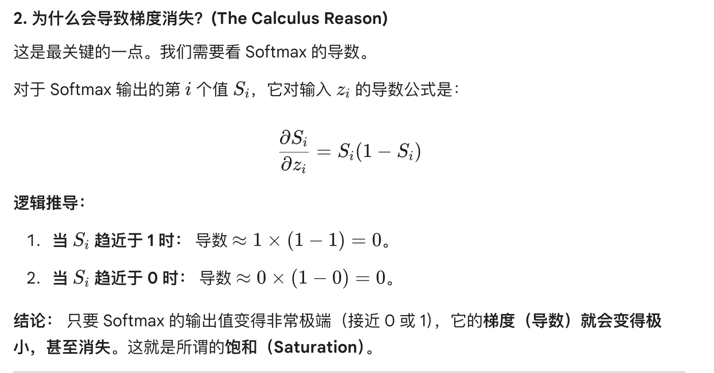

- Third, the solution: dividing by dk**0.5 scales the variance back to 1. This ensures that the softmax output has a gentler distribution, keeping the gradients large enough for stable and efficient training.

- Instead of using a single large attention head, transformers use multi-head attention. What are the primary advantages of this design in terms of learning different types of relationships?
- Mechanism of multi-head attention: multi-head attention sets different weight matrix Qi, Ki, Vi to calculate the attention scores, and concatenate all the outputs of each heads together.
- Primary advantages of multi-head attention: multi-head attention can get diverse information by using different weight matrices, which can make the attention scores more reliable.

- Firstly, Learning in diverse subspaces: by using different weight matrices for each head, the model can project the same input into different representation subspaces（表示子空间）. This allows the model to focus on different aspects of the data simultaneously
- Secondly, Capturing different types of relationships: different heads can learn to attend to different types of information. For example, one head might focus on syntactic（语法上的/语义上的）relationships (like subject-verb agreement), while another head focuses on semantic relationships (like pronoun resolution or distant context). A single head would likely “average” these relationships, losing detail
- Thirdly, improved training stability: MHA acts similarly to an ensemble of models. By aggregating information from multiple heads, the final output is more robust（稳定性/鲁棒性） and less sensitive to the noise or initialization of a single attention calculation

- Since the transformer architecture has no recurrence or convolution, it is “permutation invariant”. Explain what this means and why positional encoding is essential for understanding natural language?

- Meaning of “permutation invariant”: transformer calculate attention scores among all tokens parallelly, which makes it lose order information, so transformer architecture is permutation invariant because of attention mechanism
- Role of position encoding
  - Position encoding provides absolute or relative position information by adding into the raw token embedding, which can decrease the bad side of losing order in attention mechanism
  - Position encoding can affect query, key and value representation

- Meaning of permutation invariant（置换不变性）: because the self-attention mechanism treats the input as a “Bag of Words（词袋模型，形容没有顺序感）”, it calculates relationships between tokens based solely on their content similarity, regardless of their position. If you shuffle the order of the tokens, the output for each token remains the same
- The necessity of position encoding: in natural language, word order is crucial for meaning. To compensate for the lack of recurrence or convolution, transformers must inject structural information into the model
- The role of positional encoding
  - Injecting order: by adding a unique positional vector to each token embedding, the model can distinguish the same word at different positions
  - Capturing distance: it allows the model to learn absolution positions or relative distances between tokens, which directly affects how Q and K interact
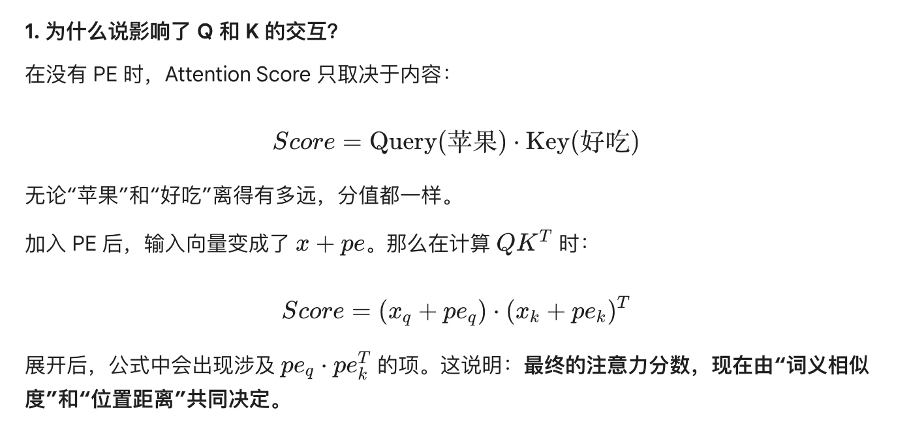

Evaluation
- Perplexity: Suppose you are evaluating two decoder-only models in the same sentence: “I love machine learning”. The probability for each token predicted by the models are as follows
  - Model A: [0.5, 0.4, 0.8, 0.9]
  - ModelB: [0.1, 0.1, 0.2, 0.1]
- Without performing exact calculations, which model has a lower Perplexity?
- In model evaluation, does a lower PPL indicate better or worse model performance? Briefly explain why in terms of “uncertainty”

- Model A has a lower perplexity
- Definition of perplexity: perplexity measures the performance of language model when predicting the next token on the generation task, which can also measure how well a probability model predicts a sample.
- A lower PPL indicates better model performance
  - Relationship between PPL and loss: PPL = exp(loss). If PPL is lower, then loss is lower, which means a better performance

- Identifying the lower perplexity model
  - Model A has the lower PPL
  - Reason: Perplexity is inversely proportional to（和某东西成反比） the probability assigned to the ground-truth sequence. Since Model A assigns much higher probabilities (0.4~0.9) to the correct words than Model B, it is less surprised by the data. PPL和模型给真实Token分配的概率成反比。由于模型A给正确词汇分配的概率远高于模型B，它对数据的惊讶程度更低
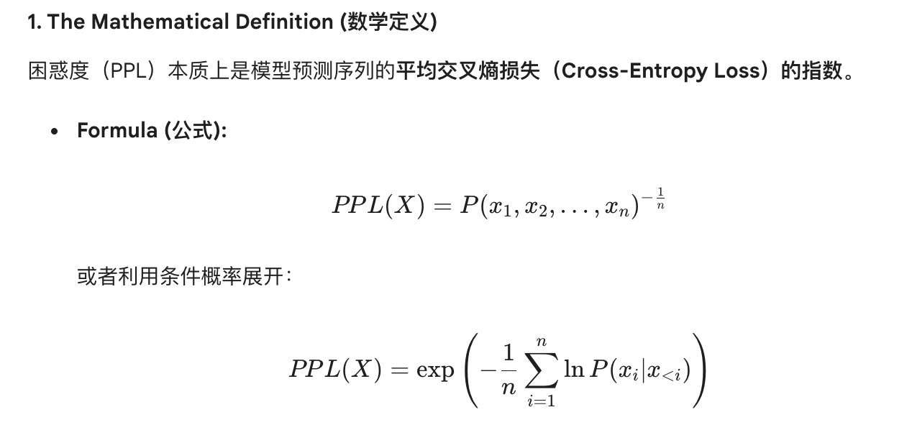
- Performance Interpretation
  - A lower PPL indicates better performance in NTP
  - Mathematically, a PPL of k means the model is as confused as if it had to choose uniformly from k possibilities. Lower PPL means the model has effectively narrowed down the search space 在数学上，PPL等于k意味着模型的困惑程度相当于是在k个等概率选项中做选择。PPL越低，说明模型有效的缩小了搜索空间
  - PPL and Loss: PPL is defined as the exponential of the average cross-entropy loss PPL=exp(Loss). Since the training objective is minimizing cross-entropy, minimizing PPL is mathematically equivalent to the model’s optimization goal 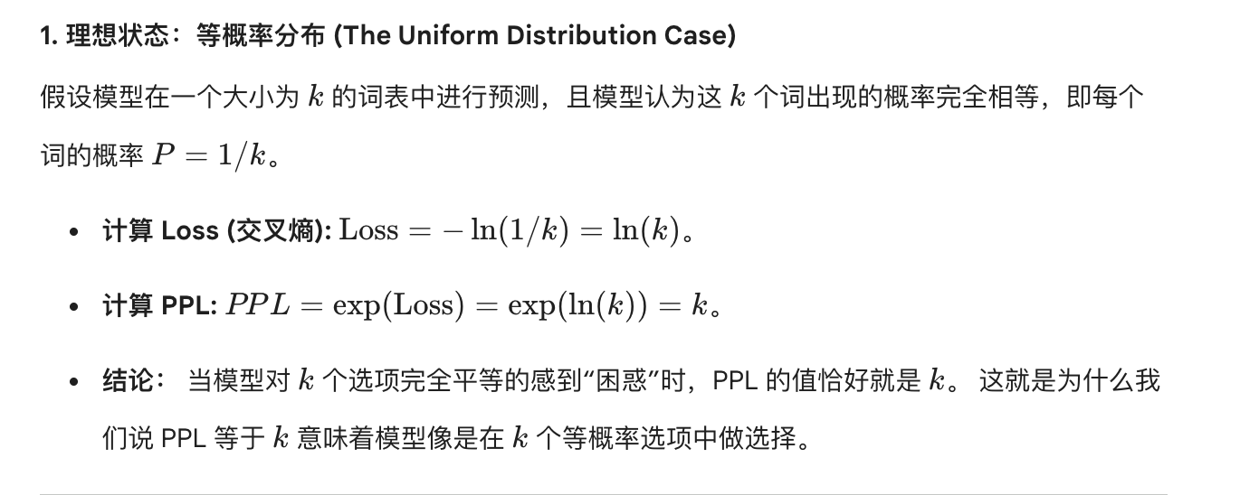
- 注意：如果两个词表的大小不同，PPL是不能直接比较的，因为词表越小，PPL通常天然越低（因为词表越小的模型，其搜索空间也越小）

- The lower perplexity model
  - Model A has a lower PPL
  - Reason: PPL = exp(loss) while loss = -sum(lnP(xn|x1, …, xn-1))/n (negative log likelihood，负对数似然函数) , which means that if PPL increase, then P(xn|x1, …, xn-1) decrease (they are inversely proportional). We can see from these probabilities that Model A has a higher probability on tokens than Model B. Hence, Model A has a lower PPL.
- Performance interpretation
  - Lower PPL means a better performance
  - Reason
    - If PPL is k, it means that the model has to choose uniformly on the search space with k samples. Lower PPL means model have a more valid search space with less samples in the search space.
    - The relationship between PPL and loss: PPL = exp(loss). If PPL is smaller, then loss is smaller, which means the model has a better performance cause loss is smaller.

- Trade off between decoding and evaluation: If you use Greedy Search for text generation, it often results in very low PPL, yet human evaluation might rate the output as poor. Explain this phenomenon considering factors like “repetition” and “diversity”

- Definition of greedy search: greedy search chooses the token with the highest probability in the decoding step. In that case, we can add a higher log probability on the joint probability of loss function. By the relationship between loss and PPL, PPL = exp(loss): higher joint probability means lower loss, which also means lower PPL. Hence, greedy search can lead to lower PPL.
- Why the output is poor in human evaluation: by the limitation of greedy search, it will always choose the token with the highest probability without considering diversity. Hence, it will lead to boring and repetitive tokens (cause there might be some tokens always having the highest probability). Hence, human rate it as poor output.

- Why Greedy Search leads to lower PPL
  - Maximizing local probabilities: greedy search selects the token with max probability as each step. By consistently picking the most “predictable” tokens, the model stays within high-probability regions of the state space, resulting in a lower average negative log-likelihood loss and thus a lower PPL.
  - The path of least resistance: greedy search follows the most certain path, which mathematically minimizes the surprise or uncertainty measured by PPL. 贪婪搜索遵循最确定的路径，这在数学上最小化了PPL所衡量的惊讶程度或者不确定性
- Why human evaluation is poor
  - Lack of semantic richness: high-probability tokens are often generic or functional（通用词或者虚词）） words (e.g., the, is, of). Always choosing the most likely token leads to safe but bland outputs that lack the information density and spark of natural human language 缺乏语言丰富度：高概率的token通常是通用词或者虚词，始终选择最可能的词可能会导致结果安全但是平淡，缺乏自然语言的信息密度或者灵性
  - Repetition loops: greedy search is prone to getting stuck in local optima, causing the model to repeat phrases indefinitely because that sequence remains the most probable at each step 贪婪搜索容易陷入局部最优，导致模型无限重复短语，因为在每一步中，该序列依然是概率最高的选项

- Architecture vs Metrics
  - Why is PPL commonly used to evaluate GPT-style models but rarely used to evaluate the original BERT model (hint: think about the difference between NTP and MLM)
  - For a seq2seq model performing a translation task, what is the most common automatic evaluation metric? Does it score based on N-gram overlap or semantic vectors?
- Why PPL is for GPT-style model not for BERT model
  - Model type and training objective difference: GPT-style model is decoder-only architecture, while BERT-style model is encoder-only architecture. Decoder-only model use next-token prediction as training objective, while encoder-only model use masked language modeling as training objective
  - Why PPL is more useful for next token prediction task
    - Definition of PPL: PPL = exp(loss), and PPL measures the performance of a language model when predicting the next token when given previous tokens. This definition aligns with the next token prediction loss function.

- Why PPL is for GPT but not for BERT（PPL适合generative task，而generative task一般使用decoder-only/Encoder-Decoder架构，比如GPT/Llama等任务）
  - Alignment with Generative Objectives: PPL is mathematically derived from the probability of a sequence P(w1, …, wn). Since GPT-style models (decoder-only) use next-token prediction, they learn to model this exact joint probability. Thus, PPL directly measures how well the model has learned the data distribution
  - The bidirectional conflict in BERT: BERT(encoder-only) uses masked language modeling, where it predicts a token wi based on both left and right context. Because BERT can see future tokens, it does not define a valid auto-regressive probability for a sequence. Calculating a standard PPL for BERT would be cheating and mathematically inconsistent with its bidirectional nature. BERT泗洪MLM，它基于左右上下文预测词汇。由于BERT可以看到未来的词汇，它无法为一个序列定义有效的自回归概率。为BERT计算标准PPL相当于作弊，并且在数学上和其双向特性不一致
- Evaluation for seq2seq translation（seq2seq属于Generative tasks，因为模型必须从词表中逐个选择token来构建一个全新的序列，而不是从预定义的标签中做选择。generative tasks可以使用BLEU、ROUGE、PPL来作为评估指标，其中BLEU/ROUGE衡量的是生成结果和标准答案像不像，而PPL衡量的是模型对这个序列感到多困惑）
  - The common metric for translation is BLUE
  - Scoring mechanism: BLEU scores based on N-gram overlap between machine-generated translation and human-written reference translations. It does not use semantic vectors; instead, it measures precision by counting how many 1-grams, 2-grams, etc. , are shared between the sequences

- Evaluation shift in post-training: you are currently working on the post-training pipeline. You have a base model and an instruct model (after SFT)
  - On the same test set, you observe that the PPL decreases significantly after SFT. What does this indicate about the model’s ability to handle instructions?
  - During the alignment phase (after DPO), you notice that PPL slightly increases, yet humans find the model more helpful. Why does this discrepancy between PPL and human preference occur? What is the model sacrificing to gain better alignment?

- Reason why PPL decrease after SFT
  - Definition of SFT: SFT is a fine-tuning process where a pre-trained model is trained on instruction-input-output pairs, enabling it to understand and follow natural language instructions across diverse tasks.
  - Reason: After SFT, the model updates parameters by minimizing log likelihood of the next token given previous tokens, which also means maximizing the likelihood of the next ground truth token. In that case, loss decreasing will lead to PPL decreasing because of the relationship between loss and PPL (PPL = exp(loss))
  - It indicates that the model learns how to generate next token perfectly on the specific domain
- Alignment sacrifice the probability of the next token to get a better token

- Why PPL decreases significantly after SFT
  - Domain adaptation to instruction formats: SFT updates the model’s parameters using high-quality instruction-response pairs. By maximizing the likelihood of ground-truth tokens in the training set, the model’s surprise or uncertainty regarding the instruction format decreases SFT使用高质量的指令-回答对来更新模型参数。通过最大化训练集中真实token的似然概率，模型对指令格式的惊讶程度或者不确定性降低了
  - Performance indication: this indicates that the model has successfully learned the template and structural patterns of human-like responses. It has transitioned from a general “next-word prediction” to a specialized”instruction follower” 这表明模型已经成功的学会了人类回答的模版和结构化模式
- Why PPL increases after alignment
  - The difference between probabilistic fit and human preference: PPL measures how well the model predicts the exact tokens in the test set (usually SFT data). However, alignment focuses on preference learning, which prioritizes qualities like helpfulness and safety over literal token limitation 概率拟合和人类偏好的差异：PPL衡量的是模型预测测试集中（通常是SFT数据）精确token的能力。然而，对齐侧重于偏好学习，它优先考虑有用性和安全性等特质，而非字面上的tofen模仿
  - The model is sacrificing its probabilistic fit to the broad distribution of the SFT data to focus on a narrower, more desirable subset of outputs. This shift in the probability mass away from the general SFT distribution causes PPL to rise, even though the resulting outputs are more useful to humans. 模型正在牺牲其对SFT数据广泛分布的概率拟合，以专注于更窄、更理想的输出子集。这种概率分布从通用SFT分布中偏移的现象导致了PPL的上升，尽管生成的输出对人类来说更有用

Modern LLMs
- SFT
  - What is the primary difference between the data format used in SFT versus the data used in pre-training?
- Scale
  - SFT use smaller dataset
  - Pre-training use large-scale dataset
- Label
  - SFT use labeled dataset
  - Pre-training use unlabeled dataset
- Domain
  - SFT use domain-specific dataset
  - Pre-training use lots of different domains dataset

- Data structure & form
  - Pre-training: uses massive amounts of raw, unlabelled text (e.g., common crawl, wikipedia).
  - SFT: use specific instruction-input-output triplets (or prompt-response pairs).
- Learning objective
  - Pre-training (self-supervised): the model performs self-supervised learning by predicting the next token in any given text. There are no explicit answers, only the natural continuation of text
  - SFT (supervised): the model performs supervised-learning where it is explicitly told.
- Data intent & Diversity
  - Pre-training: focuses on knowledge and grammar. It covers as many domains and languages as possible
  - SFT: focus on alignment. It teaches the model how to follow human intent, format its output and adopt a specific helpful tone.

- Decoding strategies & the diversity metric
  - If we increase the temperature parameter during decoding, how does it affect the probability distribution and the resulting diversity of the text?
  - Explain the mechanism of top-p sampling. How does it decide the size of the candidate token pool at each step
- Effect of increasing the temperature during encoding
  - If increasing the temperature parameter, the softmax probability of high prob tokens will decrease, while the softmax probability of long-tail tokens will increase. Hence, the probability distribution will be smooth than the original one
  - The resulting diversity of the text: may sample low-quality tokens which makes the output tokens unstable; but it can help the model escape from the local optima; cannot filter the low-probabilty tail
- The mechanism of top-p sampling
  - Set a threshold value p first and sort the tokens probabilities. Accumulate the probability of tokens from the highest prob token until the accumulated sum is over the threshold p.
  - The threshold p can control the size of the candidate token pool

- Effect of increasing temperature
  - Probability distribution: increasing T flattens the probability distribution. By dividing logits by a larger T, the relative difference between high-probability and low-probability tokens is reduced, making the distribution more uniform.
  - Resulting diversity: higher temperature increases diversity by giving long-tail tokens a higher chance of being sampled. While this helps the model escape repetitive loops and local optima, it also increases the risk of generating incoherent or hallucinated text. 较高的温度通过赋予长尾token更高的采样机会来增加多样性，虽然这有助于模型跳出重复循环和局部最优，但是同时也增加了不连贯和幻觉文本的风险。
- Mechanism of top-p sampling
  - Core logic: top-p sampling selects the smallest set of tokens whose cumulative probability mass exceeds a threshold p. Unlike top-k, which uses a fixed number of tokens, top-p dynamically adjusts the pool based on the model’s confidence. Top-p采样选择一个最小的token集合，其累计概率总和超过阈值k
  - Deciding the pool size: if the distribution is sharp (high confidence), the pool size will be small (only a few tokens needed to reach p); If the distribution is flat (low confidence), the pool size will expand to include more tokens until the sum p is met

- Perplexity as a relative metric
  - We know PPL = exp(loss). If you are comparing two models on a benchmark, why must you ensure they use the same tokenizer to make the PPL comparison valid?
- Different tokenizer means different number of vocabulary set, which will also affect the length of the subtoken sequence.
- PPL is sensitive to the size of the vocabulary set
  - Definition of PPL: PPL measures how well a probability model predicts a sample. It represents the average number of choices the model is confused by at each step.
  - If the size of the vocabulary set is smaller, it means that the candidate pool is smaller, which can lead to less confused about the choice

- The branching factor sensitivity: PPL represents the weighted average branching factor. If model A has a vocabulary of 10000 and model B has 100000, model A naturally has a smaller search space at each step. Comparing their PPL is unfair because model A is essentially taking an easier multiple-choice test with fewer options. PPL代表加权平均分叉因子。如果模型A的词表大小为10000，而模型B为100000，模型A在每一步的搜索空间天然更小。直接比较他们的PPL是不公平的，因为模型A本质上是在参加一个选项更少的多选题考试。
- Sequence length and normalization: different tokenizers split the same text into different numbers of tokens. Since PPL is calculated as exp(total loss/N), if N is larger then the PPL is smaller cause a tokenizer that over-segments text (切分的越细，vocab size越小，因为可复用性越强）will artificially deflate the average loss per token, resulting in a misleadingly lower PPL 不同的分词器会将同一段文本分成不同数量的token，由于PPL的计算公式为exp(loss/N)，一个过度切分的文本会认为稀释每个token的平均损失，导致PPL虚低
注意：vocab size变大表示切分变粗，同时vocab size变大则意味着search space变大，会导致PPL变大（注意，不可以用公式PPL=exp(loss/N)来判断，因为里面的N是token数，而不是vocab size；同时过度切分意味着vocab更小，而不是更大）
总计：切分的越细==>vocab size越小==>模型的search space变小==>PPL变小
切分的越粗==>vocab size越大（可复用的token变少）==>模型的search space变大==>PPL变大
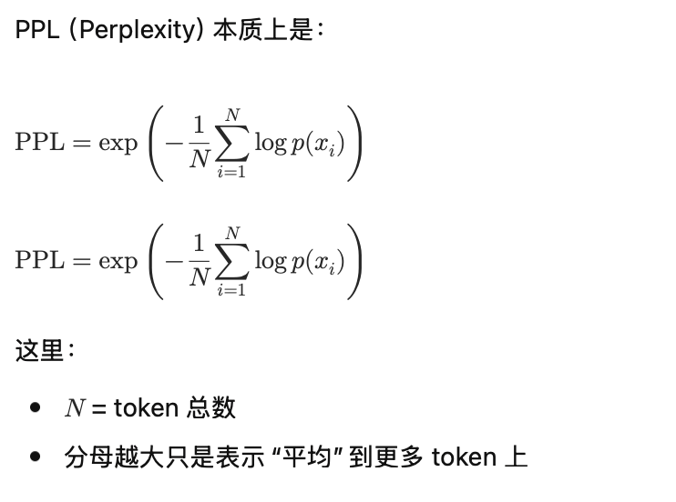

Tokenizers and Retrieval Augmented Generator
- According to the distributional hypothesis, Word2Vec learns semantic representations, but it has significant limitations in handling Out-of-Vocabulary (OOV) words. Please explain why traditional Word-based tokenizers lead to OOV issues and how this affects the model's representation learning?

- Reason why word2vec has OOV problems: word2vec gets the target embedding and context embedding by training on the given corpus. If word2vec meet with raw word in test time, it will have error cause the raw word is unseen in the training corpus
- Why traditional word-based tokenizers lead to OOV issues: traditional word-based tokenizers split the sentence into fine-grained words. For example: “I love NLP” can be split into “I”, “love”, “NLP”. However, when we get the embedding of “She loves NLP” during test time, “loves” has the similar meaning of “love” but this word never appears in the training corpus, so we can’t get the word embedding. In conclusion, word-based tokenizers lead to OOV issues because the splitting method is too fine-grained.
- How this affects the model’s representation learning: raw words don’t have embeddings
- Impact on representation learning
  - Missing features: unseen words lack high-quality numerical features (embeddings), forcing the model to rely on a generic [UNK] token, which wipes out the original semantic meaning of that position
  - Degraded contextual quality: OOV tokens introduce noise into the sequence, preventing the model from effectively capturing complex dependencies and lowering the overall precision of the representation

- Why word2vc and word-based tokenizers lead to OOV issues
  - Static vocabulary constraint: word2vec embeddings are mapped to a fixed vocabulary defined during the training phase. If a word does not appear in the training corpus, the model cannot perform a lookup for its specific index, leading to an error or an OOV status Word2Vec的向量空间大小在训练结束的时候就已经固定了，如果测试的时候出现训练语料中没有出现过的词，会导致模型找不到对应的行索引来提取向量（word2vec）
  - Lack of morphological understanding: word-based tokenizers treat each word as an atomic unit, failing to capture sub-word relationships (Morphology). For instance, a model may have learned an embedding for “dog” but treats “dogs” as a completely unknown token, missing the inferent semantic link between singular and plural forms 词级分词器将每个单词看作是独立的实体，无法理解单词内部的构成（比如前缀、后缀）。例如，即使模型见过“dog”，面对“dogs”的时候会将其视为完全不同的新词，无法复用已经有的语义知识（word-based tokenizers）
- 对表示学习的影响
  - 特征缺失：由于新词没有embedding，模型被迫使用占位符[UNK]，导致该位置的原始信息被彻底抹除
  - 性能下降：在计算相似度或者处理长序列的时候，OOV词会阻断上下文的特征传递

- Word2Vec is noted for failing to capture morphological relations (e.g., "dog" vs "dogs"). How do subword tokenization techniques address this by breaking down words, and how does this simultaneously help reduce the overall vocabulary size?

- How do subword tokenization techniques address this by breaking down words
  - For subword tokenizers, e.g., BPE, it can split the “dogs” into “dog” and “s”. In that case, the model can find the relationship between “dogs” and “dog”, so the subword-based tokenizer can capture morphological relations
- How does this simultaneously help reduce overall vocabulary size
  - For example: “She loves dogs”, “I love dog”. For word-based tokenizers, its vocabulary set could be “She, loves, dogs, I love, dog”. But for subword based tokenizers, its vocabulary set could be “She, love, dog, I, s”, which can reduce the vocab size by splitting the word more detailed

- How do subword tokenization addresses morphology and reduces vocabulary size
  - Capturing morphological relations
    - Sub-unit decomposition: subword techniques like BPE break words down into smaller, semantically meaningful components 拆分逻辑：子词技术（比如BPE）将单词分解为更小的、更加具有语义的但愿
    - Representation generalization: by splitting “dogs” into “dog” and “s”, the model can represent unseen inflected forms by combining the learned embeddings of the root word and the suffix, effectively capturing the relationship between singular and plural forms 知识复用：通过将dogs拆分为dog和s，模型即使没有见过dogs，也可以利用已知的dog和s的向量来合成表示
  - Reducing overall vocabulary size
    - Eliminating redundancy: instead of storing separate embeddings for every variation of a word (e.g., love, loves, loved, loving), subword tokenizers store a compact set of shared roots and affixes 组合爆炸的压缩：词级分词需要为单词的每种变形存储独立的向量，子词技术只需要存储基础的词根和常用的后缀，就可以通过组合表达无穷的变体
    - Efficient handling of rare words: since rare words are decomposed into a combination of high-frequency subwords, the model does not need to allocate dedicated vocabulary slots for every unique string, drastically shrinking the size of the embedding matrix 处理罕见词：通过将罕见词拆分为更加高频的子词组合，模型不再需要为每个低频词分配专门的embedding空间，从而大幅度的降低了显存占用

- Your notes mention that LLMs have "memory limits" and are "static." Combining this with the concept of RAG (Retrieval-Augmented Generation), explain why simply increasing model parameters (the deep networks in your mind map) is insufficient for real-time knowledge updates, and what role the Retrieval Model plays here?
- Why simply increasing the model parameters is insufficient for real-time knowledge
  - Everytime we want to introduce new knowledge, we have to fine tune the model to update the model parameters. However, this method is quite expensive because we need to get the training dataset, and GPU to train our model. What’s more, it takes a long time to train the model cause the model may have billions of parameters;
  - However, RAG can solve the problem by introducing a “knowledge storage”. Each time we want to introduce new knowledge, we can just update the “knowledge storage”, which doesn’t need to update the model parameters.
- Why role the retrieval model plays
  - Retrieve the related information from the “knowledge storage”, which can decrease the length of the context effectively because LLM is limited to the context window size.

- Limitations of parametric knowledge
  - Training latency: LLM knowledge is static and locked within fixed parameters. Updating this knowledge requires re-training or fine-tuning, which involves prohibitive GPU costs and long processing times 训练滞后性：LLM的知识存储在固定的模型参数中，是静态的；要更新知识，需要重新训练或者微调，这会导致极高的算力和时间成本
  - Memory saturation: simply increasing deep network parameters (model width/depth) cannot capture the infinite, ever-changing details of the real world, often learning to hallucinations 记忆限制：即使增加模型深度，模型也无法记住世界上所有的动态细节，并且容易产生幻觉
- The RAG Advantage for real-time updates
  - External storage: RAG treats the knowledge base as an external plug-in. Introducing new information only requires updating the data index rather than the model parameters, enabling near-instant updates RAG将知识存储在外部数据库，更新知识只需要更新索引，无需改动模型参数，实现了近乎瞬时的知识同步
- The essential role of the retrieval model
  - Precision filtering: the retrieval model identifies the most relevant “top-k” document snippets from a massive external corpus based on the user’s query 检索模型负责从海量外部文档中找出和当前的query最相关的top-k的片段
  - Overcoming context constraints: LLMs are limited by their context window size. The retriever acts as an efficient filter, ensuring that only the most pertinent information is presented to the generator, thereby providing accurate answers without overwhelming the model’s processing capacity. LLM的上下文窗口有限制，检索器通过过滤无关信息，确保只将最关键的知识喂入模型，从而在不增加模型负担的情况下提供准确的回答

- When building the retrieval stage of RAG, dense representations are commonly used. Explain the objective of the contrastive loss function when training such a retriever? In practical engineering, how do “in-batch negatives” improve training efficiency?

- Objective of the contrastive loss function when training a retriever
  - Pull the embedding of positive documents near to the embedding of the query, and push the embedding of negative documents away from the embedding of the query, which can improve the retrieval quality of retrievers and can recall most related documents
- How do “in-batch negatives” improve training efficiency
  - If we use all the documents to get the negative samples, it will increase the computational cost and time of the contrastive loss. By using “in-batch negatives”, it can improve the cost and time by using only a few negative documents.

- Objective of the contrastive loss function
  - Spatial alignment: The goal is to map both the query q and the document p into a shared high-dimensional embedding space 空间对齐：将查询q和文档p映射到同一个高维空间中
  - Distance optimization: the loss function is designed to pull the query embedding closer to the relevant positive document embeddings, while pushing it away from the irrelevant negative document embeddings 通过最小化该损失，使得查询向量靠近相关的正向文档向量，同时远离不相关的负向文档向量
  - Improving recall: this “pull and push” mechanism ensures that the most semantically related documents receive the highest similarity scores during the retrieval phase 这种机制保证了在检索阶段，最相关的文档能够被分配到最高的相似度分数
- How in-batch negatives improve training efficiency
  - Computation reuse: within a single training batch, each query has its own corresponding positive document. In-batch negative sampling treats the positive documents of other queries in the same batch as negative samples for the current query 计算复用：在训练的一个batch中，每个样本都有自己的一个positive document，我们将同一个batch内其他样本的positive documens当作是当前query的负样本
  - Reduced sampling overhead: this technique eliminates the need to explicitly sample or store separate negative documents from a massive corpus for every query, drastically saving memory 减少采样开销：这种方法不需要为每个query专门从海量库中搜索或者存储额外的负样本，极大的节省了内存空间
  - Accelerated training: by processing multiple negative comparisons within a single matrix multiplication, it significantly decreases the time required for backpropagation and gradient updates 加速训练：通过在一次矩阵运算中处理多个负样本，显著缩短了反向传播的时间

Sparse Attention
- Fixed/Predefined Patterns
- Sliding window attention
  - Advantages of sliding window attention over self-attention：普通的self attention是O(n^2)的复杂度，然而sliding window的复杂读是O(nw)，因为每个token只能看到附近的w个token
    - Training and inference are faster because there are fewer Qi*Kj computations
    - Lower memory usage because fewer attention values are needed
    - It captures local context effectively, which is often good enough for learning nearby dependencies and local patterns
  - Limitations of sliding window attention
    - Sliding window attention cannot directly capture long-range dependencies. Since each token can only attend to tokens within a fixed local window, it may miss important information that appears far away in the sequence
    - For example, in the sentence “The underberg drink that I shared with wei-chiu yesterday, which was recommended by Kilian, is really tasty.”. When predicting or interpreting “tasty”, the model may need to connect it back to “the underberg drink”. If the window is too small, “tasty” cannot directly attend to “underberg drink”, so the model may fail to capture that long-distance relationship
  - How stacking more transformer layers help
    - When sliding window attention in a single transformer layer cannot capture long-range dependencies, if we stack many transformer layers, something interesting happens
      - Layer1: token sees its immediate neighbors
      - Layer2: it indirectly sees neighbors-of-neighbors
      - Layer3: information keeps propagating outward.
      - So after many layers, a token can indirectly access distant tokens, even though each individual layer only uses local attention
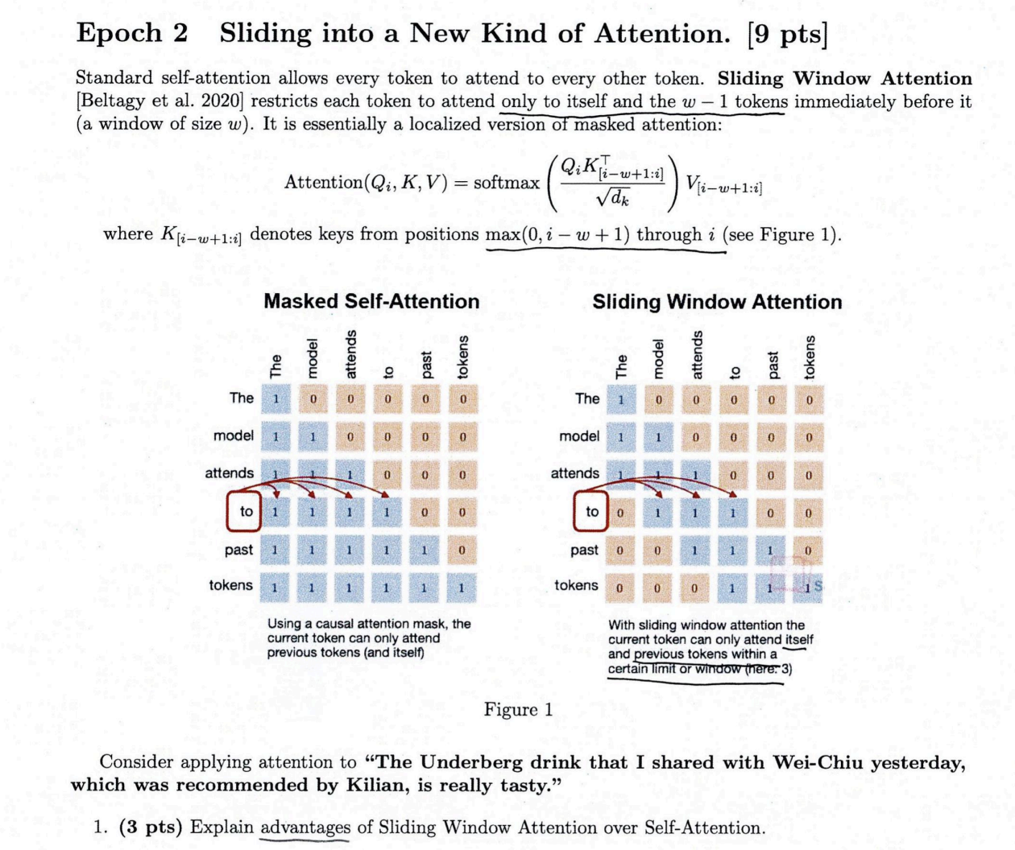


  - Global Attention
    - Motivation: 在标准的self-attention中，每个token都需要关注其他的token，计算复杂度为O(N^2)，而在global attention中，系统会指定少数的token（global token），这个token这可以关注序列中的每个token，序列中的每个token都可以关注这个global token
      - Example：比如下面NLP final example题目中，所有的偶数点就是global attention，即使t和t-100相距很远，由于t能看到偶数点，t-100也能看到同一个偶数点，所以信息通过这个中间人只需要两层就可以传递
    - Advantages
      - 全局视野：可以解决长距离依赖问题
      - 效率很高：线性时间复杂度，并且拥有N_max的感受野
    - Limitations
      - 信息瓶颈：在全局模式下，少数几个全局token需要承载整个序列的汇总信息，然而向量的维度是有限的，强迫一个固定长度的向量去编码成千上万个词的复杂关系，可能会导致信息丢失
      - Rigid inductive bias：指的是模型对数据规律的假设，像题目B中强制偶数位作为global token，或者Longerformer强制[CLS]作为global token，这是一种static的假设，如果文本的逻辑重点刚好不在设计的global token上，模型就会产生盲区
      - 梯度传播的中心化风险：几乎所有的梯度更新都需要经过global token来传播。如果global token的权重在训练初期初始化的不好，或者在学习过程中陷入了局部最优，会导致模型难以训练，并且梯度消失或者梯度爆炸很容易在global token发生
  - Dilated Attention
    - Advantages
      - Larger receptive field: captures long-range dependencies across massive sequences without adding layers 不需要增加层数或者参数，就可以覆盖更长的上下文
      - Lower computation than full attention
      - Low memory: enables processing of much longer sequences on standard hardware
    - Limitations
      - Miss local details: if dilation=4, it will see t-4, t-8, t-12, and it will ignore t-1, t-2
      - Rigid inductive bias: a fixed dilation rate may not adapt well to diverse linguistic structures 固定的扩张步长无法根据内容动态调整注意力
    - Solution
      - Multi-dilation setup: assigning different dilation rates to different heads (some heads focus on local, others on global)
      - Sliding window hybrid: using standard local attention for immediate neighbors and dilated attention for distant tokens 将标准的局部Attention和Dilated Attention结合
    - Complexity: O(nk), only attend to k tokens

- Content-Adaptive
  - Clustering/Hashing Attention
  - Routing/Top-k Attention
- NLP final example question
